**ATAR 12 Physical Education Studies**

**Unit 3 and 4**

***Motor Learning and Coaching***

Name: ___________________________

*TIME ALLOWED FOR THIS PAPER*

Reading time before commencing work: Five minutes

Working time for paper: Fifty minutes

Section 1 - Multiple Choice 5 questions – 5 marks available

Section 2 - Short Answer 5 questions – 21 marks available

Section 3 - Extended response 2 questions – 30 marks available

Total marks available: 56

**Section 1 Multiple Choice**

5 Questions, Answer all questions on this page by circling or highlighting the correct response.

1. Which of the following statements best describes an authoritarian coach?

(a) A netball coach allows the players to pick their own positions for the last quarter of the game.

(b) A hockey coach meets with each individual player at the start of the season to consult with them regarding their personal goals for the year.

(c) A basketball coach confers with his coaching staff which players should start the game.

(d) A soccer coach deciding who will be captain for the game on the weekend.

1. When Physical Education teachers introduce new skills, they explain and demonstrate the skill, normally reinforcing key teaching points. This teaching strategy is an example of which type of transfer of learning?
2. Skill to Skill
3. Proactive Transfer
4. Training to Competition
5. Theory to Practice
6. Coaches use video footage and observational checklists to assist athlete performance. These are examples of
7. Qualitative Analysis
8. Quantitative Analysis
9. Subjective Analysis
10. Motion Analysis
11. Different teams and varied situations are suited to particular styles of leadership. An autocratic style is best suited when:
12. The team is full of experienced older players.
13. The team cares more about social cohesion compared to task cohesion.
14. Player’s skills must be improved to enact a difficult game plan.
15. Players have ideas about preparing better for games.
16. The athlete practices the triple jump by sequentially combining the run-up, hop, step and jump phases. This is an example of
17. Shaping
18. Front loading
19. Progression
20. Chaining

**Section 2 Short Answer**

5 Questions, Answer all questions in the space provided, if you require additional pages please use the spare pages in the back of the test paper and clearly indicate which question you are addressing.

Question 6 **(6 marks)**

An athlete that engages in reflective learning is one who is readily involved in seeking and analysing feedback and information to improve sporting performance.

(a) Identify the stages that an athlete would undertake when engaging in the reflective learning process. (4 marks)

_____________________________________________________________________________________________________________________________________________________________________________________________________________________________________________________________________________________________________________________________________________________________________________________________________________________________________________________________________________________________________________________________________________________________________________________________________________________________________________________________________________________________________________________

(b) Describe one method of reflection that the athlete could use during the process.

(2 marks)

____________________________________________________________________________________________________________________________________________________________________________________________________________________________________________________________

Question 7 (4 marks)

There are several different coaching strategies a coach can employ during a training session to improve the execution of selected skills. For example, teaching a skill as a static drill or as a dynamic drill. Explain, with relevant examples, two other coaching strategies that may be utilised during a session.

________________________________________________________________________________________________________________________________________________________________________________________________________________________________________________________________________________________________________________________________________________________________________________________________________________________________________________________________________________________________________________________

Question 8 (6 marks)

Your friend approaches you about her poor performances recently in her State League Netball games. She is seeking some advice from you about how to get back to playing at her best.

1. Discuss how your friend could use video analysis of the game and /or a checklist of her skills to improve her performance.

_____________________________________________________________________________________________________________________________________________________________________________________________________________________________________________________________________________________________________________________________________________________________________________________________________________________________________________________________________________________________________________________________________________________________________________________________________________________________________________________________________________________________________________________

Question 9 (2 marks)

Of the two augmented feedback types; prescriptive (describing the problem and prescribing the solution) or descriptive (describing the problem), justify which is more appropriate for a performer in the early associative phase of learning.

____________________________________________________________________________________________________________________________________________________________________________________________________________________________________________________________________________

Question 10 (3 marks)

In the image below (Figure 1) an attacking player is practicing their goal scoring capacity using a header whilst the goal keeper is also training their defensive skills – undertaken in a game-like environment.

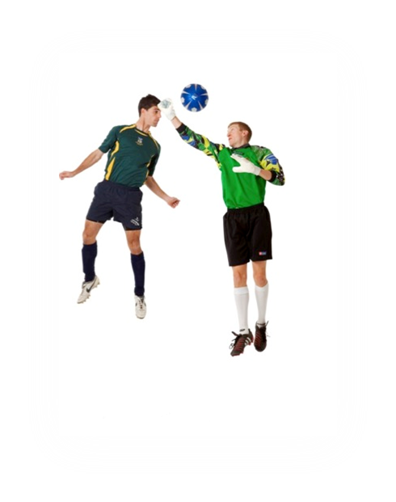

Figure 1 Players undertaking a game-like simulation at training

1. Identify the type of transfer of learning this situation represents. (1 mark)

________________________________________________________________

(b) Identify two ways the practice should imitate the game-like situation. (2 marks)

____________________________________________________________________________________________________________________________________________________________________________________________________________________________________________________________________________

**Section 3 Extended Responses**

Answer both Questions in the space provided. If you run out of space please use the additional pages at the end of the booklet clearly marking which question you are addressing.

Question 11  **(15 marks)**

16 year old, Mikayla George is in training to become Australia’s first indigenous aerial skier. Similar to others before her, such as Lydia Lassila, Alisa Camplin, and Kirstie Marshall, Mikayla originally competed in gymnastics, before converting to aerial skiing.

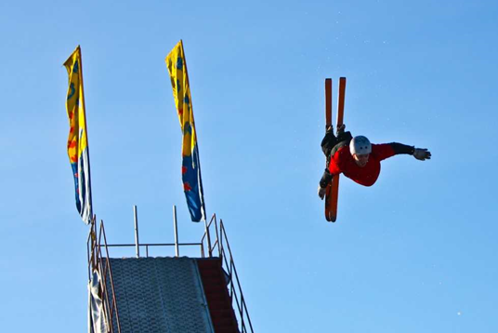

1. Define Transfer of Learning, and explain two factors that may have an impact on transfer. (3 marks)

________________________________________________________________________________________________________________________________________________________________________________________________________________________________________________________________________________________________________________________________________________________________________________________________

1. Identify and explain the type of transfer that Mikayla may have experienced during the swap to aerial skiing. Using examples, discuss the effects of transfer of learning Mikayla may encounter during her transition. (12 marks)

________________________________________________________________________________________________________________________________________________________________________________________________________________________________________________________________________________________________________________________________________________________________________________________________________________________________________________________________________________________________________________________________________________________________________________________________________________________________________________________________________________________________________________________________________________________________________________________________________________________________________________________________________________________________________________________________________________________________________________________________________________________________________________________________________________________________________________________________________________________________________________________________________________________________________________________________________________________________________________________________________________________________________________________________________________________________________________________________________________________________________________________________________________________________________________________________________________________________________________________________________________________________________________________________________________________________________________________________________________________________________________________________________________________________________________________________________________________________________________________________

Question 12 **(15 marks)**

Figure 13. The javelin throw (a) and throwing a vortex (b)

Figure (a) Figure (b)

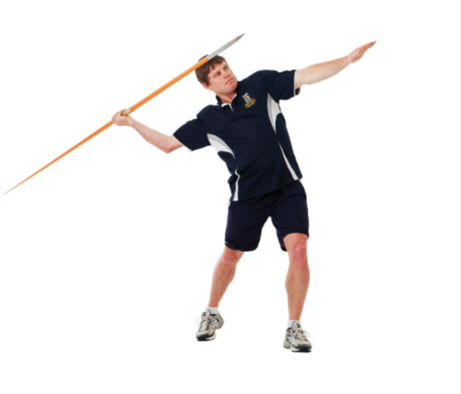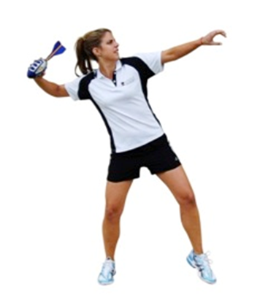

1. When learning to perform a standing javelin throw, a Year 8 PE teacher might ask the students to first use a vortex rather than a javelin. Define both chaining and shaping and identify which method is being used by the teacher. (3 marks)

________________________________________________________________________________________________________________________________________________________________________________________________________________________________________________________________________________________________________________________________________________________________________________________________________________________________________________________________________________________________________________________________________________________

1. An example of a visual cue is ‘enhancing the visual environment’ to assist the learners understanding of how to execute the task. Identify and describe the key qualities of two other visual cues that could be used by a PE teacher. (4 marks)

________________________________________________________________________________________________________________________________________________________________________________________________________________________________________________________________________________________________________________________________________________________________________________________________________________________________________________________________________________________________________________________________________________________

1. The Year 8 PE teacher, when teaching javelin to a class of 30 students, is concerned for student safety and providing the best learning opportunities. Describe two leadership styles that are less suitable when organising and teaching the students to throw javelins. Also, justify with three reasons to account for the leadership style that is most appropriate. (8 marks)

________________________________________________________________________________________________________________________________________________________________________________________________________________________________________________________________________________________________________________________________________________________________________________________________________________________________________________________________________________________________________________________________________________________________________________________________________________________________________________________________________________________________________________________________________________________________________________________________________________________________________________________________________________________________________________________________________________________________________________________________________________________________________________________________________________________________________________Sprare Pages ___________________________________________________________________________________________________________________________________________________________________________________________________________________________________________________________________________________________________________________________________________________________________________________________________________________________________________________________________________________________________________________________________________________________________________________________________________________________________________________________________________________________________________________________________________________________________________________________________________________________________________________________________________________________________________________________________________________________________________________________________________________________________________________________________________________________________________________________________________________________________________________________________________________________________________________________________________________________________________________________________________________________________________________________________________________________________________________________________________________________________________________________________________________________________________________________________________________________________________________________________________________________________________________________________________________________________________________________________________________________________________________________________________________________________________________________________________________________________________________________________________________________________________________________________________________________________________________________________________________________________________________________________________________________________________________________________________________________________